|  |
| --- |
| TECHNICAL REPORT |

|  |
| --- |
| Electrical & Computer Engineering & Computer Science (ECECS) |

|  |  |
| --- | --- |
| SPRING 22 |  |



Contents

Project Name 2

Executive Summary 2

Technical Report 3

Highlights of Project 3

Submitted on: 3

Abstract 4

Methodology 5

Results Section 5

Discussion 6

Conclusion 6

Contributions/References 7

## Submitted on: 05/03/22

|  |
| --- |
| Project Name **Netflix Recommendation System** |

|  |  |  |
| --- | --- | --- |
| Executive Summary The Netflix Recommendation System is many using to suggest movies to users. These recommendations are based on the movie ratings, movie release dates and the user’s preferences. The audience retentions on the shows also plays a major role. The Model used in this project is ALS, which takes in all the parameters and based on the show ratings, it recommends the movies or shows based on them. | | |
| person at a table writing in a notebook with people around | | |
| **Team Members:**  **Ujwal Nagulapalli**  **Prajwal Reddy Nallamaddi**  **Narayana Reddy Danda** | **Questions?**  Contact : +1 4758370457 |  |

|  |  |
| --- | --- |
|  |  |
|  |

## Abstract

The project plans to investigate and separate insights from the Netflix information utilizing the ideas of Cloud Computing. The objective of the undertaking is to carry out Pearson Correlation Coefficient and Alternating Least Squares calculations with the assistance of PySpark. Film Recommendations is executed utilizing Collaborative Filtering utilizing pySpark on Netflix Data. This undertaking's essential point is to give film proposals to the client in view of their inclinations.

Executive Summary

Introductory Section

Netflix is a membership based real time feature that permits its individuals to sit in front of the TV shows and films without ads on a web associated gadget. Netflix presents an enormous assortment of TV shows, motion pictures, narratives across a wide scope of class and dialects. It proposes clients to watch different TV shows and motion pictures. Netflix utilize their proposals framework that depends on an AI calculation that considers your previous decisions in motion pictures, the kinds of classifications you like, and what moves were watched by clients that had comparative preferences like yours. Recommender frameworks at Netflix length different algorithmic methodologies like support learning, brain organizations, causal displaying, probabilistic graphical models, lattice factorization, groups, crooks.

Netflix's proposal frameworks have been created by many architects that examine the propensities for a huge number of clients in view of different variables. At the point when a client gets to Netflix administrations, the suggestions framework assesses the likelihood of a client watching a specific title in light of various factors, for example, watcher association with Netflix, time term, the gadget client utilized, the time a watcher watches, etc. A suggestion framework is a subclass of Information separating Systems that tries to anticipate the rating or the inclination a client could provide for a thing. In basic words, a calculation proposes applicable things to clients for instance on account of Netflix which film to watch.

Likewise, Netflix cooperative based separating prescribes the new watch rundown to clients considering the interest and inclination of other comparable clients. Recommender frameworks or proposal frameworks shapes a class of information and data separating framework that guides in foreseeing the taste and inclinations of a client. Cooperative sifting handles the likenesses between the clients and things to perform suggestions Meaning that the calculation continually tracks down the connections between the clients and in-turns does the proposals.

## Methodology

The vital thought behind Collaborative Filtering is that comparative clients share comparative interest, individuals with comparable interest will in general like comparative things. Cooperative sifting is generally utilized for recommender frameworks. Consequently, those things are prescribed to comparable arrangement of clients.

Content-based sifting made their expectations considering the qualities of your watch history Movies web-based features utilize both all the while to come by the best outcomes.

In this project, we will be using following approach

* Examine the info Netflix information utilizing SPARK
* Execute Collaborative sifting calculation.
* Execute the methodology in a Jupyter Notebook utilizing SPARK on AWS EMR bunch.
* Run the execution to foresee the evaluations for all client thing matches.
* Figure the Mean Absolute blunder and the root mean squared mistake for the forecast.

Recommender System

A recommender framework is a sort of data sifting framework. By drawing from colossal informational collections, the framework's calculation can pinpoint precise client inclinations. When you know what your clients like, you can suggest them new, significant substance. Netflix, YouTube, Tinder, and Amazon are on the whole instances of recommender frameworks being used. The frameworks tempt clients with significant ideas in view of their decisions.

Advantages of Recommender System

* Expansion in deals on account of customized offers.
* Upgraded client experience.
* Additional time spent on the stage.
* Client maintenance on account of clients feeling comprehended

Utilizing AI, recommender frameworks give you ideas in a couple of ways:

• Collaborative Filtering

• Content-based Filtering

• Hybrid (Combination of Both)

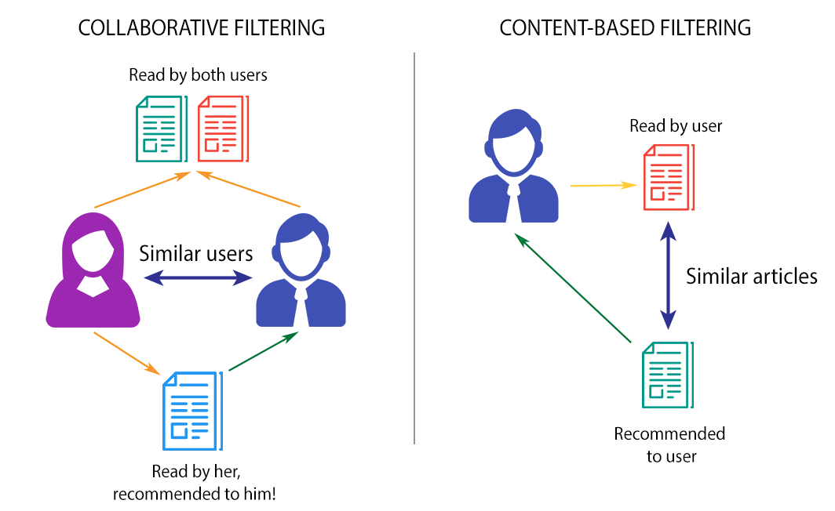

Collaborative Filtering

A cooperative separating recommender framework investigates similitudes among clients and additionally thing connections. When the framework recognizes similitudes, it serves clients proposals. As a rule, clients see things those comparable clients loved. Cooperative separating is a procedure utilized by recommender frameworks. Cooperative sifting channels data by utilizing the communications and information gathered by the framework from different clients. In view of the thought individuals who concurred in their assessment of specific things are probably going to concur again from now on. The idea is basic: when we need to track down another film to watch we'll frequently ask our companions for suggestions. Normally, we have more prominent confidence in the suggestions from companions who offer preferences like our own.

Most cooperative separating frameworks apply the purported closeness file-based strategy. In the area-based approach, a few clients are chosen considering their likeness to the dynamic client. Induction for the dynamic client is made by ascertaining a weighted normal of the evaluations of the chose clients. Collaborative-filtering systems focus on the relationship between users and items. The similarity of items is determined by the similarity of the ratings of those items by the users who have rated both items.

There are different types of collaborative filtering systems including:

• Item-item Collaborative Filtering

• User-user Collaborative Filtering

Item-item Collaborative Filtering

An item-item algorithm analyzes product associations taken from user ratings. Clients then, at that point, see suggestions considering how they rate individual items. For instance, you rate a film as a 10/10. Presently, you will see the top of the line films with comparative credits.

User-user Collaborative Filtering

The other sort of cooperative separating thinks about the comparability of client tastes. In this way, client cooperative sifting doesn't serve you things with the best appraisals. All things considered, you join a bunch of others with comparative preferences, and you see content in view of noteworthy decisions.

Suppose you use Netflix interestingly. You play a Sci-Fi Movie. The framework bunches you with different clients who additionally like Sci-Fi. Then, at that point, the Netflix suggestion framework shows you different films picked by clients in your group. Your more decisions, the more significant the outcomes.

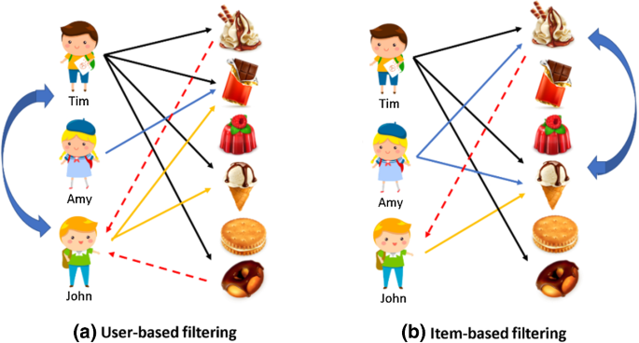

## Steps to Run the Project

Steps for uploading and analyzing the data

• Uploading the data from S3 bucket

* Specifying the DataFrame Schema

• Cache the data

Rather than reading the data again and again from S3 bucket. Lets cache both movie

DataFrame and rating DataFrame in memory.

• Average estimated overlap

For accurately estimating the similarity, lets pick a user from the test set and extract the item the user rated in the training set compare it with other users on the training set. let's look for comparison statistic with the overall average of items of that user and perform the same for other users in test set to get an idea of estimated average overlap. now continue the same for items instead of users to get the estimated average overlap of users for items.

• Splitting the dataset into training and the validation

* Model based ALS for Mean square error (MSE) and Root mean square error (RMSE).

• Movie ratings

## Results Section

The below are the results that are generated from the ALS Model, we will be getting the Movie Id along with the ratings for that movie id. The model is trained meticulously with the approach we have just mentions

In case you need to run statistical models, you might turn to regression models (or categorical analysis. You can also report results from other empirical techniques that fall under the general rubric of data mining. Note that many reports in the business sector present results in a more palatable fashion by holding back the statistical details and relying on illustrative graphics to summarize the results.

## Discussion

The ALS Model takes in the movie rating along with the movie id. The ALS model is trained on these data, based on the user rating. These recommendations are based on various input parameters. The ALS model is trained on propriety data such that recommendations does not have any errors. The model is robust to handle the outliers and the data patterns to recommend the movie or shows to the users.

## Conclusion

We were able to recommend the shows/movies to the users based on their genre preference, users’ attention to different shows, the unit performance to different parameters. We have the movie id and the corresponding movie to each user. We have successfully recommended multiple movies/shows to user, to allow user to pick from them. These recommendations are useful to company, as they allow the user to interact with the platform more thereby improving the revenue to the Netlix.

## Contributions/References

https://ir.netflix.net/ir-overview/profile/default.aspx

https://help.netflix.com/en/node/412 https://towardsdatascience.com/tensorflow-for-recommendation-model-part-1-19f6b6dc207d